**Zadify**

Zach Durtschi

* **Executive summary**

Zadify is an Android OS application that will provide users with “gamification” of real life goals. Users will be able to set goals, track their progress in a game-like scenario, then earn rewards upon completion of those goals. Zadify will provide default goal types and rewards, but the user will also be able to create his or her own variations. Zadify will provide a variety of rewards and ways to interact with other users, including earning ranks and items, sharing accomplishments with friends, and creating goal competitions. Zadify will be developed through Mono for Android—using Microsoft’s Visual Studio and C#—and the project will be completed in ten weeks, from 7 January to 15 March 2012.

* **Project description**

Difficulties with motivation and following through with goals are common problems today. Many people have made so many new resolutions, start new diets, and create new plans that they have come to expect failure more than success. Zadify aims to help users get motivated for any task through gamification, creating rewards for task completion that would not otherwise exist. Gamification is not a new concept – applications such as Badgeville, Foursquare, and Fitocracy gamify businesses, travel, and exercise, respectively – but few applications work on a broad scale, and even less are free. Zadify will have built in rewards and goal templates, but users will also be able to make custom goals and rewards, allowing Zadify to track users’ progress in any goal. Goals can also be set between multiple users to create a competition. When users succeed in enough goals, they will earn ranks, which will reward them with titles. These titles can be shared with other users. The rewards and competitions will provide the users with something to work towards when performing otherwise mundane tasks, which will provide the motivation and desire to follow through where the tasks do not.

* **Project requirements**

The requirements are shown below, with a solid bullet in front of them. Outlined bullets under each requirement indicate more detailed descriptions of that requirement. Constraints on those details follow in brackets, each divided by commas.

The system should…

* Have goals
  + Following predefined goal templates[exercise, time management, diet, reading, writing, finance]
  + Following user-defined goal templates[allows the user to create their own templates]
* Track users’ goal progress
  + Using a monster chase scenario[goal elements represented by scenario elements: deadline by monster distance, progress by items found to fight off the monster]
* Have rewards
  + Ranks[awarded upon user fulfillment of predetermined numbers of goals completed]
  + Prizes[awarded per rank, additional monsters and items for monster chase scenario]
  + User-defined rewards[allows the user to create custom rewards and completion requirements, unlocks upon user fulfillment of user’s requirements]
* Have settings
  + User profile[allow changing of active user, log in to Zadify network]
  + User information[name, gender, height, weight]
  + Application appearance[color of application elements, font]
* Allow the user to view and edit stored information
  + Goals[all goals in short summary, individual goals in detail, sortable by type, color-coded to indicate nearly expired or expired, provide user with a way to create a new goal while viewing goals]
  + Rewards[reward types in short summary, rewards of each type in short summary, individual rewards in detail, sortable by amount completed, provide user with a way to enter a new reward while viewing rewards]
  + Settings[all settings in summary, user information in summary]
* Allow the user to share activity and accomplishments
  + On social networks[Facebook, Twitter]
  + On Zadify[create notifications the user’s friends can view]
* Allow the user to interact with other users
  + Friends[permission to view each other’s shared information]
  + Goal competitions[in the categories: first to complete requirements, most progress made by deadline]
  + Newsfeed[view friends’ accomplishments shared through Zadify]
* Store all information
  + Kept between sessions[no data loss unless the user deletes it]
* Run on Android OS
  + Smartphones[running 4.0 Ice Cream Sandwich or higher]
* **Project specification**

The project’s external specification is laid out through a numbered list indicating external interfaces, followed by a more detailed description.

1. User Interface
   1. Android Graphical User Interface

The user will interact with the system through his or her device’s touch screen. Each menu will contain buttons displaying each option, accessible by a touch. If the menu contains enough items that the items do not all fit on the screen at the same time, the menu will be scrollable by using a sliding touch. The user will input information through the standard Android keyboard.

The following are example layouts:

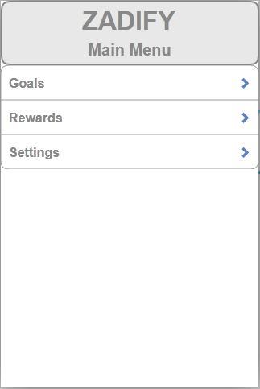

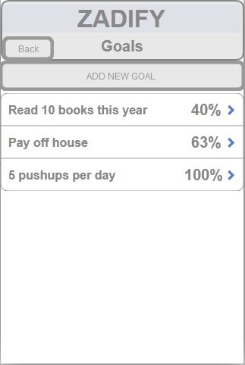

* 1. Menu Flow

While navigating through the system, the user will be able to move through each screen according to the following diagram and descriptions:

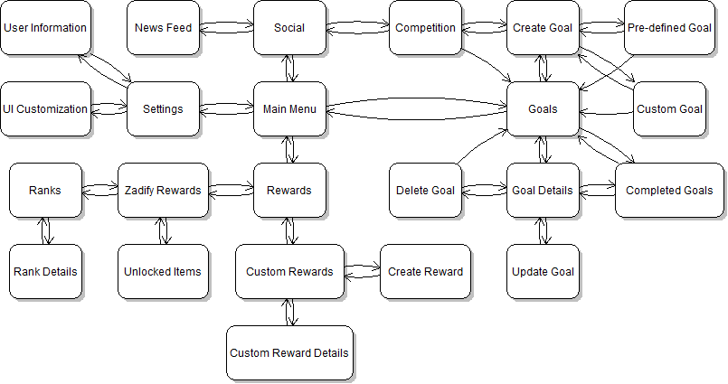

Main Menu – Displays upon startup. Gives the user a choice between viewing goals, rewards, settings, and social.

Goals – Displays a summary of all goals, as well as options to add a new goal or view completed goals. Choosing a goal brings the user to a detailed description of said goal.

Create Goal – Gives the user a choice between creating a custom goal, using a predefined goal template, or creating a competition.

Pre-defined Goal – Prompts the user to create a goal for predefined objectives.

Custom Goal – Prompts the user to create a goal for other, user-defined objectives.

Goal Details – Displays information about the chosen goal, represented in a monster chase scenario, including the description, progress, discovered items, start date and time, and time left. Gives the user options to update or delete the goal. Returns to Goals or Completed Goals depending on which one the user went through to get here.

Update Goal – Prompts the user to change the details of the selected goal, including goal progress. If the user passes a 30%, 60%, or 90% milestone, the system awards the user with the respective item. If the user finishes the goal, the system displays a congratulations message and designates the goal as completed.

Delete Goal – Prompts the user to confirm the deletion of the goal. Returns to Goals upon confirmation and deletion.

Completed Goals – Displays a summary of all completed goals. Choosing a goal brings the user to a detailed description of it.

Rewards – Gives the user a choice between interacting with Zadify rewards or custom rewards.

Custom Rewards – Displays the names of all custom rewards, as well as an option to create a new reward.

Create Reward – Prompts the use to enter information for the custom reward, as well as associating it with goals.

Custom Reward Details – Displays the details about the chosen goal that the user is allowed to see. If the user has unlocked the reward, he or she sees everything. If not, the user only sees the reward name and the requirement for unlocking the reward.

Zadify Rewards – Gives the user a choice between viewing ranks and unlocked items.

Unlocked Items – Lists all items that could potentially show up during a monster chase. If the user has seen the item, its name will be displayed; otherwise, it will be shown as a row of question marks.

Ranks – Displays a list of all ranks, from lowest to highest. Choosing a rank brings the user to a detailed description of it.

Rank Details – Displays detailed information about the chosen rank, including the conditions to reach it and the item set unlocked when the user reaches it.

Settings – Allows the user to view or change personal information and customize the UI.

User Information – Displays the user’s information and allows the user to edit it.

UI Customization – Allows the user to change the UI’s color scheme and font.

Social – Allows the user to view a news feed of friend activity or create a competition goal with friends.

News Feed – Displays a scrollable list of activities the user’s friends have posted to the Zadify network.

Competition – Prompts the user to create a goal involving one or more friends. This goal can follow a predefined template or a custom template, but must also define the way a user can win.

* **Project architecture**

Zadify will operate according to the following diagram and descriptions:

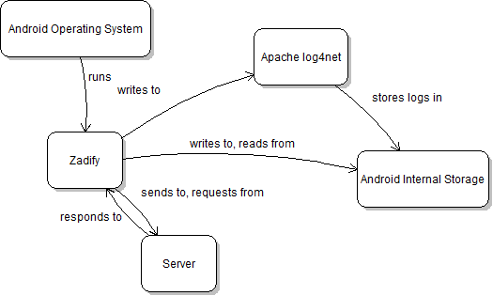

Android Operating System – The user opens Zadify using their Android Operating System, version 4.0 Ice Cream Sandwich or higher.

Zadify – The application.

Android Internal Storage – Zadify saves all information to the Android smartphone’s internal storage, and retrieves it from the same location.

Apache log4net – Zadify logs information about its execution through Apache log4net, which in turn stores the logs in the Android smartphone’s internal storage.

Server – Zadify will store all information related to the Zadify friend network on a server, which will be hosted through VMware Workstation 9.

* **Technological description**

Zadify uses the following technologies:

1. Android Operating System 4.0 Ice Cream Sandwich
2. .NET Framework
   1. Visual Studio 2010
   2. C#
   3. ADO.NET Entity Framework
3. Mono for Android
   1. Android system emulator
4. Apache log4net
5. NUnit
6. VMware Workstation 9

* **Novelty**

This project will primarily demonstrate my ability to learn and adapt to new development environments, as I have never programmed for a mobile platform before. The project development will also show my ability to overcome obstacles, such as integrating multiple media types into one application. Finally, Zadify will not just be a showcase of my skills, but will also be a genuinely useful product that anyone who needs extra motivation could use. It could potentially be placed on the market after this course, and benefit many users.

* **Development process**

The week, due date, and milestones are listed below.

Week 1 (1/17/13) – Basic menu layout

* Navigation through application
* Setup unit testing framework
* Setup logging framework
* Setup repository

Deliverables:

* Working menu navigation, following the paths outlined in Project specification
* Unit tests and logs for above features
* Working repository storage

Week 2 (1/24/13) – Predefined Goals

* Creation and storage of goals following predefined templates

Deliverables:

* Ability to create and retrieve goals
* Unit tests and logs for above features

Week 3 (1/30/13) – Ranks and friends

* Ranks based on number of goals completed
* Setup Zadify friend network

Deliverables:

* Ability to view ranks, rank requirements, and rank rewards
* Ability to log in to Zadify friend network
* Ability to add other users as friends
* Unit tests and logs for above features

Week 4 (2/7/13) – Custom Goals

* Creation and storage of custom goals
* Form to aid in goal creation without restricting the user

Deliverables:

* Ability to create and retrieve custom goals, using the form
* Unit tests and logs for above features

Week 5 (2/14/13) – Monster Chase and News Feed

* Representation of goals as a monster chasing the user
* Basic item sets, randomly chosen on goal creation
* View feed of friends’ shared activities

Deliverables:

* Ability to view goals as a monster chase
* Randomly selected item sets for each goal
* Viewable news feed of friends’ activities
* Unit tests and logs for above features

Week 6 (2/21/13) – Custom Rewards and Competitions

* Creation and sending of competition goals to friends
* Creation and storage of custom rewards
* Connection of any class of goal to custom rewards

Deliverables:

* Ability to create and view custom rewards
* Ability to associate the completion of goals with custom rewards
* Ability to compete with friends on goals
* Unit tests and logs for above features

Week 7 (2/28/13) – Settings, Additional Items, and Social Network Sharing

* UI Customization
* Edit and store user’s personal information
* Unlocking all items sets
* Share any activity on Facebook or Twitter

Deliverables:

* Ability to customize color and font of the user interface
* Ability to enter and retrieve personal information
* All item sets unlocked alongside earning new ranks
* Ability to share news on Facebook or Twitter
* Unit tests and logs for above features

Week 8 (3/7/13) – Debugging: 50% of bugs fixed

* Must pass 50% of previously failed unit tests

Deliverables:

* + Completed project except for bugs

Week 9 (3/11/13) – Final debugging and presentation

* Fully working and ready for presentation

Deliverables:

* Completed project and presentation
* **Resources**

The resources involved in Zadify’s development and deployment are listed below, with explanations after each bullet.

1. Mono for Android

Zadify will be developed using Mono for Android. Mono for Android also has Android phone emulators, with which Zadify will be deployed.

1. Visual Studio 2010

Mono for Android will run through Visual Studio 2010.

1. Github

Github will be used as a code repository to save Zadify’s progress as it is developed.

1. Apache log4net

Apache log4net will be used to maintain logs of Zadify’s runs.

1. NUnit

NUnit will be used to develop unit tests during Zadify’s development.

1. VMware Workstation 9

VMware Workstation 9 will be used to host a virtual server where Zadify’s network data will be stored.

* **Additional Information**

The following table shows what will be unlocked at each rank:

|  |  |  |  |  |  |
| --- | --- | --- | --- | --- | --- |
|  | Rank 1 | Rank 2 | Rank 3 | Rank 4 | Rank 5 |
| Monster Type | Zombie | Skeleton | Mummy | Evil Robot | Demon |
| 30% Reward – Food | Rations, Corned Beef, Apple | Lutefisk, Dried Fish, Fried Chicken | Burnt Giraffe, Honey Jar, Grape Jelly | Cake-in-a-Can, Spam, Twinkie | Angel’s Food Cake, Deviled Eggs, Divinity |
| 60% Reward – Defense | Police Uniform, Garbage Lid | Motorcyle Helmet, Knight Armor | Toilet Paper, Pop-up Tent | Haz-mat Suit, Body Armor | Platinum Suit, Sorcerer’s Robes |
| 90% Reward – Offense | Shotgun, Handgun, Board+Nail | Baseball Bat, Katana, Sledgehammer | Flamethrower, Scythe, Crossbow | Lightsaber, Laser Gun, Towel | Mace mace, Hatchet, Cleats |